**Trends of News Visualization Project**

Mr.Marwan Yeedeng

Mr.Niheng Mae

**Adviser**

Mr.Kholid Langsaree

**Overview**

The project of our team is about data visualization of Thailand News Trends Over 4 Years. We will use the study of Data mining to analyze the News of Top 10 Thailand News Agency Websites to answer the question of ours that is ***“What is the Trends of Thailand News Over 4 Years?”*** and the output of the research will be exported by using the technique of data storytelling as Data Timeline Visualization.

We will use website technology to deploy our product because the website will make our data having interaction with users and look more beautiful than just a static graph.

**Problem Statements**

The project is to the answer of the question to answer the question ***“What is the Trends of Thailand News Over 4 Years?”*** but to answer the question we need to have the data. To collect the needed data and output those as the answer of the question we need to use the field of study of data mining and its process like crisp-dm.

**Objective of Research**

* We would like to use the study of data mining to analyze the trend of news of Thai News Agencies.
* We would like to use the study of data storytelling to illustrate the trend of news of Thai News Agencies.

**Scope**

The scope of this proposed project is to use techniques of Data Mining technology to summarize the Trends of News and deploy as data visualization in from of Timeline.

**Significance of Study**

* The question of the research will be answered.
* Improve the field of study of data mining knowledge.
* Expand the body of knowledge.

**Software and Hardware Requirement**

**Resource**

* News from 10 Thailand News Agency Websites.

**Data Mining Process**

* Python
* Jupyter notebook
* Data Mining Libraries
* Pandas
* Numpy
* Requests

**Data Visualization Process**

* Web Application Languages
* Html
* JavaScript
* Css
* Data Visualization Libraries
* Matplotlib
* Seaborn

**Database**

* Spark
* Data Integration Format
* Json

**Methodology**

**Planning:** During planning the project. We will use Crisp-Dm to plan the discipline of the project. Crisp-DM or Cross Industry Standard Process for Data Mining is for planning the one of data-mining process that used to identify the step of doing data mining project.

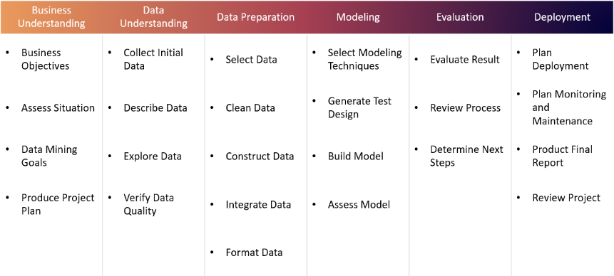

**Processing:** We will use Anaconda jupyter notebook as text-editor with Python Programming Language. Start with data acquisition by scraping from Thailand News Agencies and hen use python data science library like pandas to clean them up as a useful data that we can take and use and also summarize in term of statistical mathematics by using python and numpy.

**Deployment:** In the process of Deployment. We will deploy as statistical mathematics by using pandas and numpy. Statistical graph by using matplotlib and seaborn. Final step is using building a website to deploy our project to make it more interaction to users and using the technique of data storytelling tools to illustrate it.